Travel API Design Document

# Data Model

Data model is used determine the structure of data to make application use. There are three model created to help to show the fare information based on the search criteria.

**Airport**

Airport data model has structure of information to populate Origin and destination information in the Availability / Fare search Page.

***Sample JSON Structure***

|  |
| --- |
| {  "id" : 1,  "code" : *"AMS"*,  "name" : *"Amsterdam"*,  "description" : *"Amsterdam Airport Schiphol"*,  "country" : *"NL"*  } |

***Properties***

Id : Unique id of Airport data model.

Code : Airport code

Name : City Name

Description : Airport Name

Country : country code of Airport.

**Flight**

Flight data model is help to hold the flight information. Fight data model has one to many relationship with Fare data model.

***Sample JSON Structure***

|  |
| --- |
| {  "id": 1,  "origin": *"DXB"*,  "destination": *"AMS"*,  "validBetween": {  "start" : *"2018-01-01"*,  "end" : *"2018-02-31"*  },  "carrierCode" : *"KL"*,  "flightNumber" : *"0001"*,  "flightTime": *"7h 30m"*,  "departTime": *"08:40"*,  "arrivalTime": *"13:35"*  } |

***Properties***

Id : unique id

Origin : Origin of the flight

Destination : Destination of the flight

Valid between : mentioned date which is applicable or valid to display along with fares in fare search screen

Carrier Code : Carrier code of the flight

Flight Number : Flight number of the flight

Flight Time : Total journey time of the flight.

DepartTime : Departure time of the flight

ArrivalTime : Arrival time of the flight.

**Fares**

Fares data model is help to hold the fare information. Fares data model has one to many relationship with Fare data model.

"applicableFlights" : [1,2,3,4] -> Array of applicable flight property will hold the flight id of the flight model which are eligible for corresponding fare.

***Sample JSON Structure***

|  |
| --- |
| {  "id" : *"1"*,  "currencyCode" : *"EUR"*,  "economyFare" : *"100.5"*,  "businessFare" : *"250.4"*,  "firtClassFare" : *"1200.4"*,  "faresApplicableDate": {  "startDate" : *"2018-01-01"*,  "endDate" : *"2019-01-01"*  },  "applicableFlights" : [1,2,3,4]  } |

# add new data into data model

To add new data into data model to display airport and fares, please follow the steps,

Data model location is : .../original-case/src/main/esources/data

|  |  |
| --- | --- |
| File Name | Comments |
| airports.json | add new airport information which we need to display in **“from & to “** on booking search screen |
| flights.json | add new airports with unique id |
| fares.json | fares to display for applicable flights. we need to mention the flight id inside the applicable Flight ID property which the current fares is applicable for. |

# Fare search page

Fare search page looks like below. When user enters 2 digit of airport name / code on From or To, application will provide sugguestions based on the data from airport data model

We can access this Travel API by using this below URL.

<http://localhost:9000/travel/index.html>

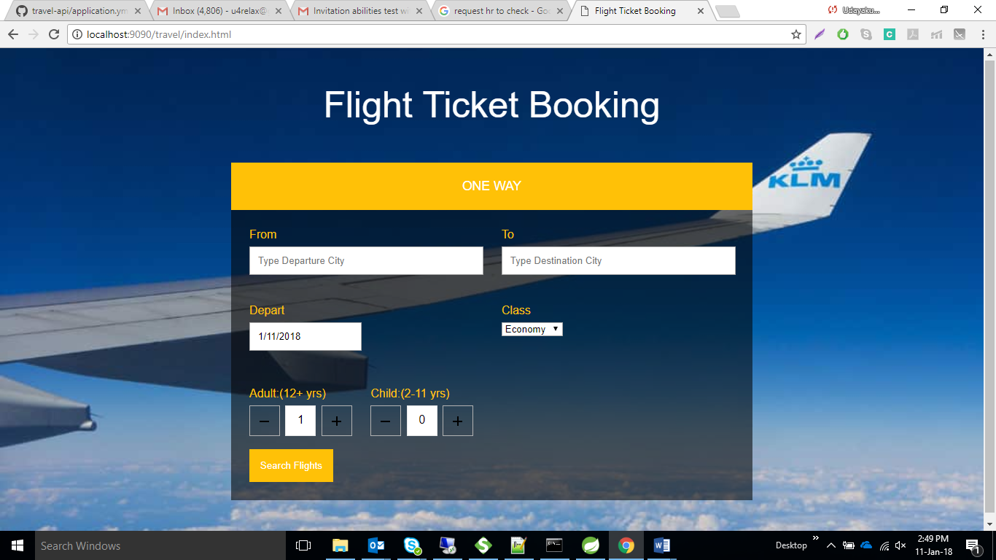

# Fare Results

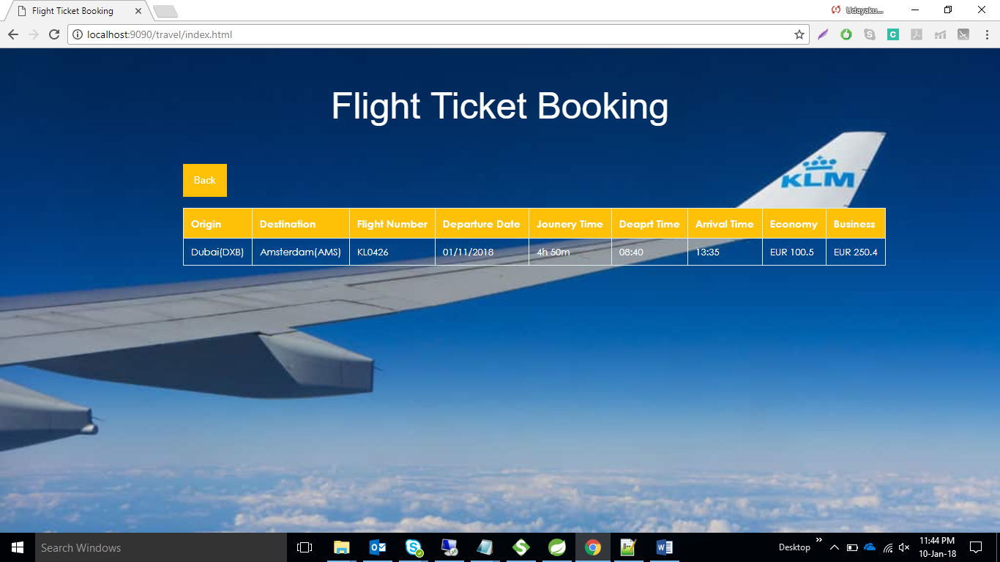

**How Search will work?**

Based on the user entered search criteria, application will find the right flights based on the origin, destination and departure date. And it will check whether any applicable fares are available for the matched flight based on the flight id which is there in fare data mode.

# Metrics

Application is enabled with Aspects to track the request which received in the application. And its keep on monitoring the each service success and failure count. And response time of the each request, and eligible to provide min, max and avg response time.

We can access this page to see the consolidate metrics by using below URL.

<http://localhost:9000/travel/metrics.html>

